Lab:03

Experiment Name: Implementation of Half Subtractor using basic gates.

**Equipment:**

1. Trainer board
2. Bread board
3. IC
4. Connecting wire
5. Wire cutter

**Theory:**

Half subtractor is the most essential [combinational logic circuit](https://www.elprocus.com/introduction-to-combinational-logic-circuits/) which is used in [digital electronics](https://www.elprocus.com/digital-electronics-flip-flop-circuit-types-and-applications/). Basically, this is an electronic device or in other terms, we can say it as a logic circuit. Half subtractor is used to perform two binary digits’ subtraction.  the subtractor circuit uses binary numbers (0,1) for the subtraction. The circuit of the half subtractor can be built with two [logic gates](https://www.elprocus.com/basic-logic-gates-with-truth-tables/). This circuit gives two elements such as the difference as well as the borrow.

Truth table of a half adder can be derived by performing binary subtraction as follows:

**Truth Table:**

|  |  |  |  |
| --- | --- | --- | --- |
| A | B | Difference | Borrow |
| 0 | 0 | 0 | 0 |
| 0 | 1 | 1 | 1 |
| 1 | 0 | 1 | 0 |
| 1 | 1 | 0 | 0 |

From the truth table Boolean expression can be derived as:

Difference, D = A’B+AB’

Borrow, B r= A’B

**Diagram:**

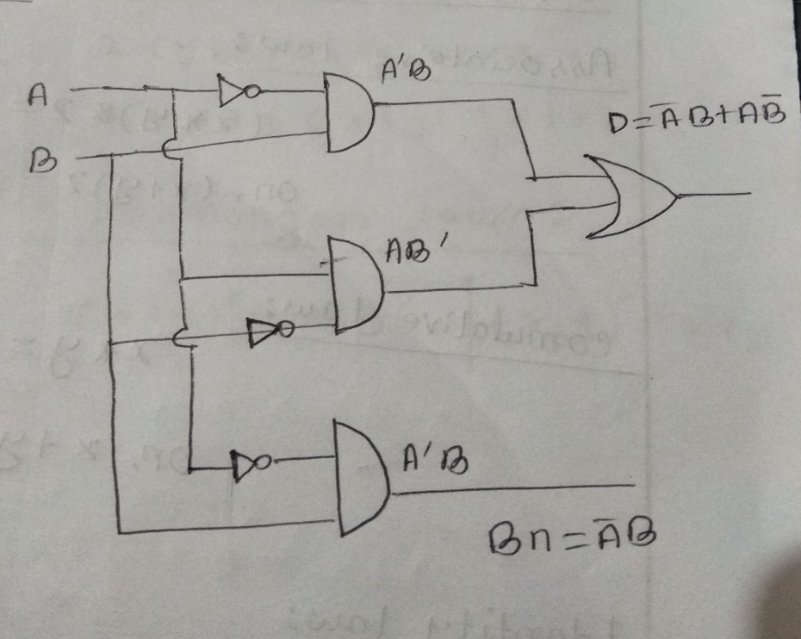

**Discussion:**

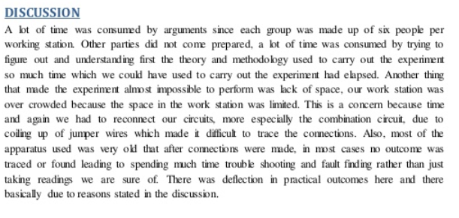

**Conclusion:**

In summary, a half subtractor is successfully demonstrated by combining the basic gates.

